Respiratory System
Why do we breathe?
Answer= our cells need energy to survive. They get this by the process of respiration. Respiration happens in all living cells. Respiration is the breakdown of glucose (a type of sugar) in oxygen to give energy.
Glucose+Oxgen Carbon Dioxide+water+energy
Breathing brings oxygen from the air into our blood. This is the oxygen used in respiration.
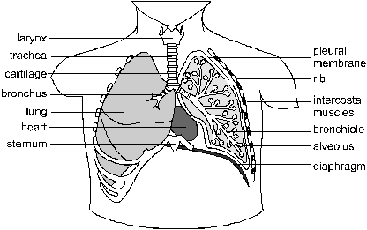
We use our respiratory system to breathe.
Breathing occurs in two stages:
Inhalation – the muscles between the ribs and the diaphragm contract which increases the space inside the lungs and air is sucked in.
Exhalation – the muscles relax causing the space inside the lungs to decrease and the air is pushed out.


